Create a simple cloud software application for Car Booking Reservation System using any Cloud Service Provider to demonstrate SaaS.

Aim
To create a simple cloud-based Car Booking Reservation System using Zoho Creator to demonstrate the SaaS model.
Procedure
- Login to Zoho Creator and create an application named Car Booking System.
- Create a Car Details form with Car ID, Car Name, Model, Type, Rent/Day, and Availability.
- Add car categories such as Hatchback, Sedan, SUV, and Luxury.
- Create a Customer Details form with Name, Contact Number, Email, and Driving License Number.
- Create a Booking Form with Customer, Car, Pickup Date, Return Date, and Booking Status.
- Add a workflow to check whether the selected car is available.
- Calculate the total rental amount based on the number of days.
- Create reports for available cars and confirmed bookings.
- Create a dashboard to display cars, bookings, customers, and revenue.
- Test and deploy the application on the cloud so users can access it through a browser.

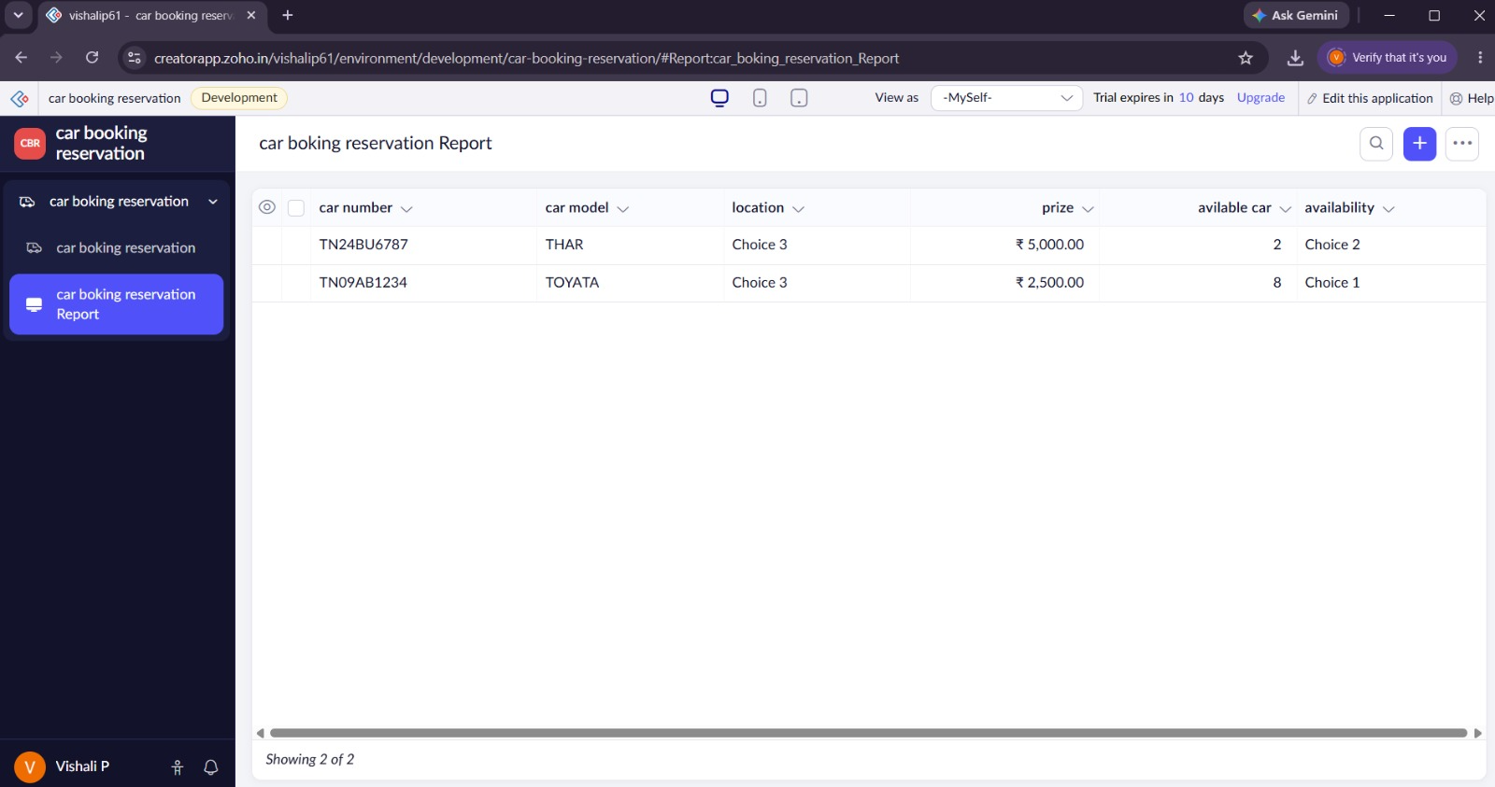
Result
A cloud-based Car Booking Reservation System was successfully developed using Zoho Creator, demonstrating SaaS.

